# Task 1

## Sample 1

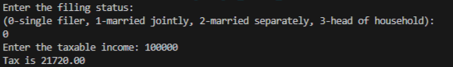

## Sample 2

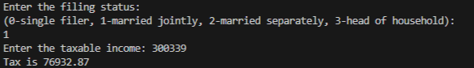

## Sample 3

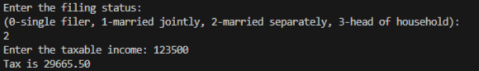

## Sample 4

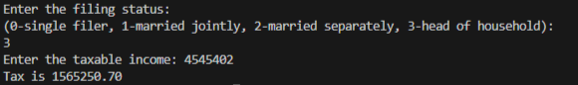

# Task 1

## Sample 1

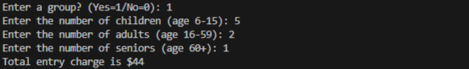

## Sample 2

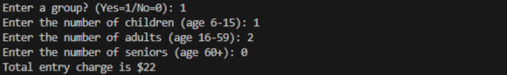

## Sample 3

